*Note Lincoln Area College Fair time change below on Oct 4th *

Monday, October 2

**9:00AM- 10:30AM**

**Lincoln Southeast High School College Fair**

**School Address: 2930 S. 37th St. Lincoln, NE 68506**

**Host Site Contact: Kelley Winter; (402) 436-1304 opt. 3,**[**kwinter@lps.org**](mailto:kwinter@lps.org)

Representatives may start setting up at 8:15 AM.  Please drop off materials and equipment to our LSE Student Ambassadors who will be available off of 37th and Otoe Street just North of Southeast Main Building Entrance (Door 6) and then proceed to park your car.  We will have Student Ambassadors available to carry your items to your assigned table.

Please see the attached map for parking and building entrance locations.  Please use street parking on Otoe, Pawnee or Melrose Ave; You will not be ticked despite the "No Parking" signage.  After parking your car please enter through the building door by the bus stop on 37th street & Otoe Street  (John Prasch Activities Center--Door 6)

We will have students or staff at the entrance door (John Prasch Activities Center--Door 6) to direct you to your assigned table. Juniors will be cleared to visit the fair from 9:00am to 9:45am and seniors will be cleared to visit from 9:45 am to 10:30am. We may have approximately 500+ students. Lincoln Standing Bear High School will also be present at our fair. They will bring a group of 25 to 40 sophomores.

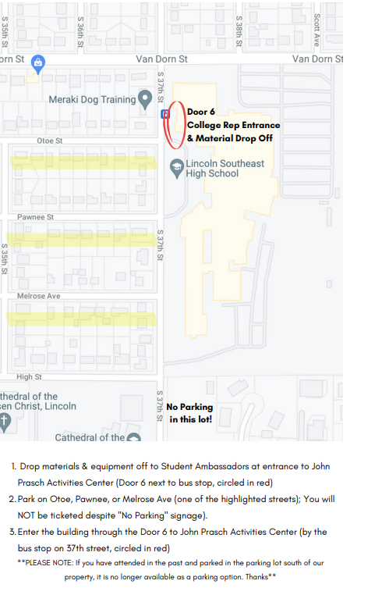

**Lincoln Southwest High School College Fair**

**1:00PM- 2:30PM**

**Lincoln Southwest High School**

**School Address:** 7001 S. 14th St, Lincoln NE

**Host Site Contact Information:** Amanda Tomes, [atomes@lps.org](mailto:atomes@lps.org), 402-436-1306 ext 66309

Event participants should park in the Southwest corner of the lot near the tennis courts (see map). Participants can enter through door #3 beginning at 12:30 p.m. We will have Student Ambassadors available to help bring in materials and locate your tables.

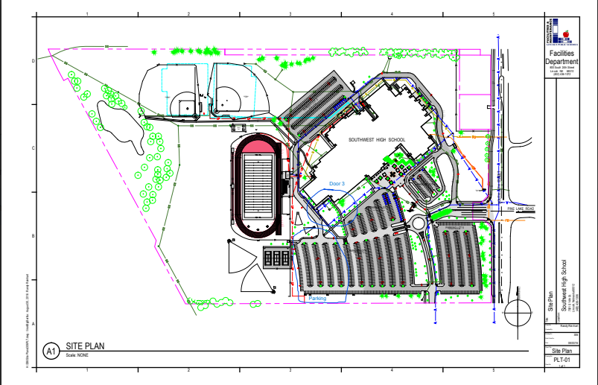

Tuesday, October 3

**Lincoln North Star High School College Fair**

**8:00AM- 10:00AM**

**North Star High School**

**School Address**: 5801 N. 33rd St.

**Host Site Contact**: Allison Brown, abrown8@lps.org

In order to avoid the traffic to get in and get set up, you will want to be here by 7 AM.  North Star has ample parking in our large student lot (which is the southeastern lot), but you will want to get here early to avoid the rush that comes at the beginning of the day (see attached map).  We ask that you enter Door 3 indicated on map.  There will be people to show you where to head into the gym to set up for the morning.

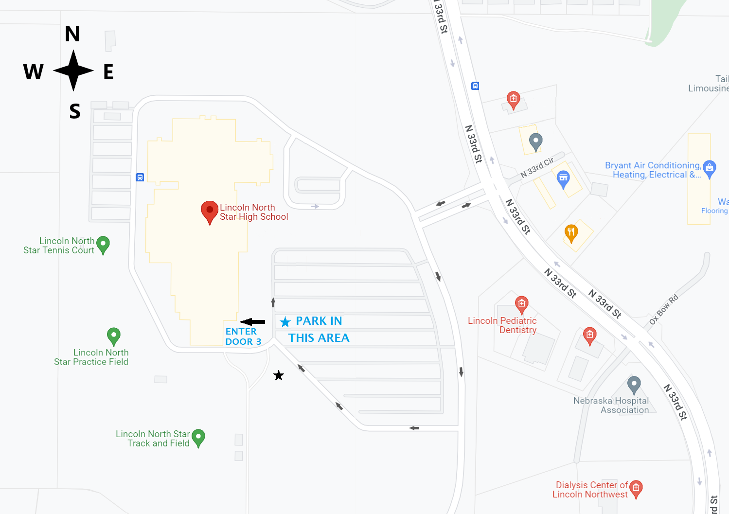

**Lincoln Northeast College Fair**

**12:30PM- 2:30PM**

**Northeast High School**

**School Address**: 2635 N. 63rd St.

**Host Site Contact Information**: Kim Davis;  [kdavis@lps.org](mailto:kdavis@lps.org)

Representatives may start setting up at 12:00PM. Reps can unload at the front of the building where the Rocket is located or the yellow dot on the map.  Student ambassadors will be there to assist.  Please enter the building through the main entrance on the east side of the building by the Rocket.

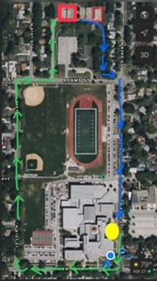

Wednesday, October 4th

**Lincoln High School College Fair**

**9:00AM- 11:00AM**

**Lincoln High School**

**School Address**: 2229 J St.

**Host Site Contact**: Renee McClure; (402) 436-1222, [rmcclur@lps.org](mailto:rmcclur@lps.org)

We will be using the Johnson Gym this year for our College Fair

which is larger than the previous gym. There is a drop off area where student

ambassadors will take the materials from your vehicle and put them on your

table in Johnson Gym while you park. After you park, there will be student

ambassadors at the front door to meet you and walk you to the Johnson Gym.



**Lincoln Area College Fair**

**1:15pm to 2:30pm *time change\***

**Southeast Community College – Lincoln Campus**

Address: 8800 O Street Lincoln NE, 68520

Host Site Contact: Bailey Michaels, [bmichaels@southeast.edu](mailto:bmichaels@southeast.edu), cell phone: 308-367-6543

Our campus is under construction so we apologize for any confusion! This event will be held in the gym. Representatives can either park in the North lot (this option is closer and easiest to get to the gym) or park in the south lot. You can enter through the main entrance (facing South), or through the T Section (facing North). The entrances into the building are indicated by the blue stars on the map below. We will have guides to lead you to the gym entrance from there. Class will be in session so parking may be limited. Reps can start setting up at 12:00pm. *84th street is open*

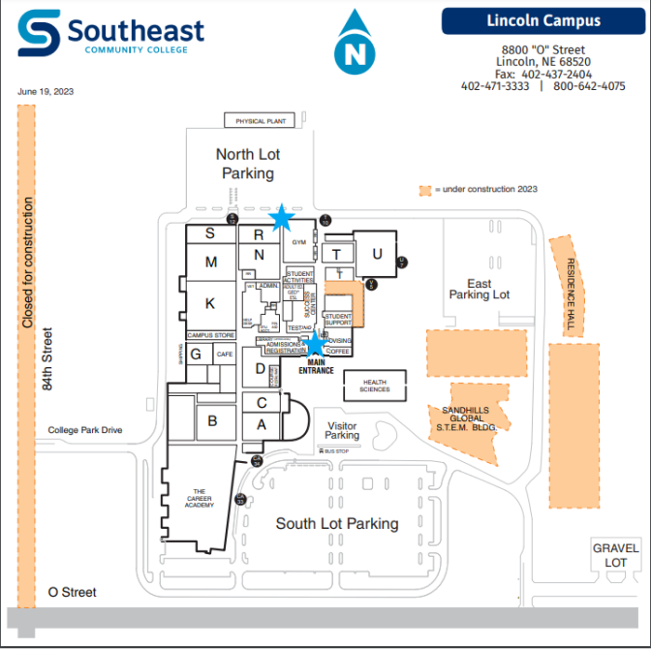

High Schools invited include: Bryan Community School, College View Academy, Conestoga, Crete, Dorchester, Elmwood Murdock, Lincoln Christian, Lincoln Lutheran, Malcolm, Milford, Norris, Palmyra/Bennett, Parkview Christian, Pius X, Seward, Waverly, Weeping Water

Thursday, October 5th

**Lincoln East High School College Fair**

**9:00AM- 10:30AM**

**Lincoln East High School**

**Address**: 1000 S. 70th St.

**Host Site Contact:** Amanda Ludwig, [aludwig2@lps.org](mailto:aludwig2@lps.org), 402-436-1302 ext. 3

Please see below map for parking information. Parking will be in Seacrest Field Home Parking lot. Enter through door #21 (starred on the map). Participants are welcome to start arriving as soon as 8:30am to begin setting up. Student ambassadors will be available to assist participants to their designated tables. Estimated 500+ East High students.

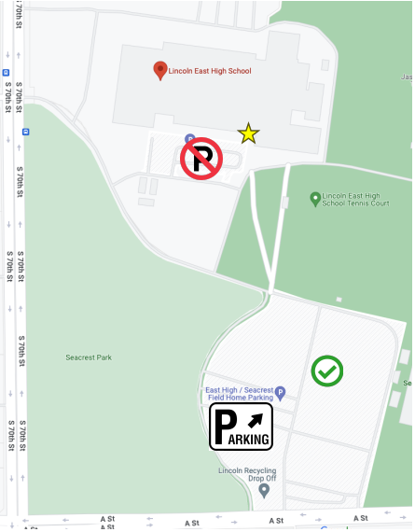

**Lincoln Northwest High School**

**1:00PM- 2:30PM**

**Lincoln Northwest High School**

**Address**: 4901 W. Holdrege Street

**Host Site Contact**: Brooke Sharpe, bsharpe[@lps.org](mailto:acarothe@lps.org), 402-436-1314

Please enter through Door 1 on the North side of the building. Secured Entrance Monitors will provide direction to the gym for setup. Entrance and gym are on the same floor (no stairs/elevated).