Hello!

The following is information for each NACRAO College Fair scheduled the week of **September 8th through September 12th.** These emails will be going out to all NACRAO Reps, if your college did not register for these fairs, please ignore as it is to assure everyone receives the information needed for travel!Please forward this information to any representatives who will be attending these events.

If you have any questions about an event, or will no longer be able to attend an event, please contact the host site directly (contact information is below). Also, check out our **Weekly Socials** below for a chance to get together with the other reps on the road!

*As a reminder we are using [StriveScan](https://www.strivescan.com/) as our college fair scanning app! Be sure to purchase a per fair you wish to attend (only one credit needed per school). If you're not familiar with StriveScan, [you can watch a quick, 2-minute video on how it works](https://urldefense.com/v3/__https:/www.strivescan.com/*intro__;Iw!!I6-y8lpfja43!uRp08Esb-nX-rHwEJ429Oqv-AwriQbasJ48XrKdbEx20y75Btm2fbheddH7Lo1MdwWyXiuZJB_Z0-olv7Xf5$).

**Monday, September 8th**

**Mullen Area College Fair**

10:00 to 11:00am (MST)

Location: Lariat Center

Address: The Lariat Gym 205 S Washington Ave, Mullen, NE 69152 (GPS not the best directions… It’s on the corner of Highway 2 and Highway 97, south of the highway across from the Kwik Stop.

Host Site Contact: Kara Connealy, Cell phone: 308-650-0747. Email: [kara.connealy@mullenpublicschools.org](mailto:kara.connealy@mullenpublicschools.org). School phone: 308-546-2223.  Please use my cell phone the day of the fair as the fair is not located at the high school. Representatives may park on any side of the Lariat.  Door entrances are on the south and east sides of the building. Reps may begin setting up any time after 9:00 am.

In keeping tradition, we will have lunch provided to you before you have to take off to Alliance.  Please [RSVP at this link](https://docs.google.com/forms/d/e/1FAIpQLSd7SMcP4juIDq9T0ZKEqi-T54VSpy4yf8DXN6aoQVR3_W7XKg/viewform?usp=sharing&ouid=103386796260160258683) your soonest convenience so we can confirm number counts for amounts needed.  Lunch will be roast beef sandwich, pasta salad, chips, grapes, and cookies.

High schools Invited: Mullen, Thedford, Dunning, Hyannis, and Valentine.

Number of Students Attending:

2025: Valentine 70-75, Thedford, 19, Dunning ?, Mullen 34

2024: Valentine 75, Thedford 18, Dunning 12, Mullen 45

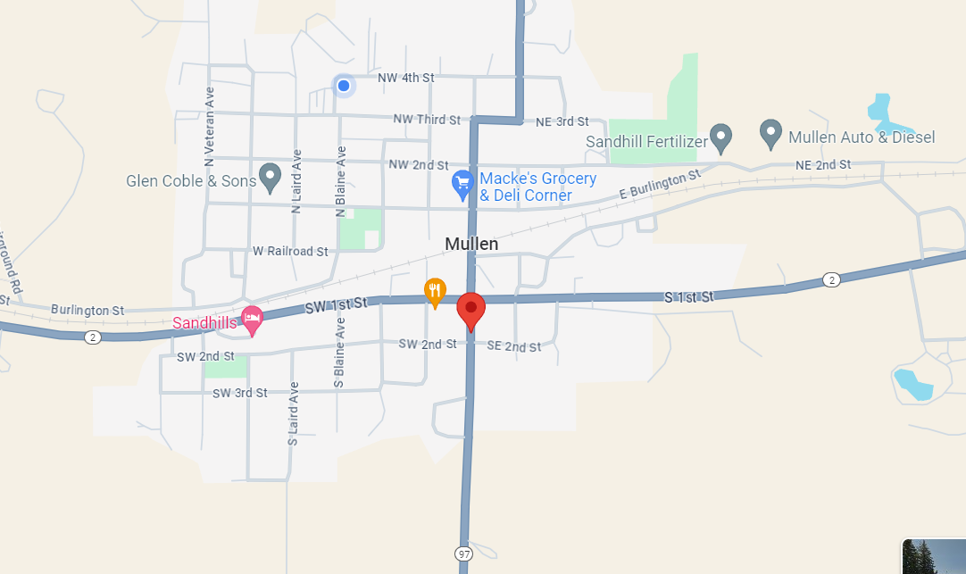

**Alliance Area College Fair**

2:00PM- 3:00PM (MST)

Location: Alliance High School

Address: 1450 Box Butte Avenue in Alliance, NE

Host Site Contact Information: Nate Lanik; [nate.lanik@alliancebulldogs.org](mailto:nate.lanik@alliancebulldogs.org)

Details: Representatives may park in the north lot or on the street of Alliance High School and can enter through the doors on the North side of the building. Reps may begin setting up any time after 1:00 pm.

High Schools Invited: Alliance High School, Hemingford High School, and Hyannis High School. Approximately 250 students are expected to attend.

**Tuesday, September 9th**

**Chadron Area College Fair**

9:00AM- 10:30AM (MST)

Location: Chadron State College – Chicoine Center Upper Concourse

Address: 375 E 12th St, Chadron, NE 693337

Host Site Contact: Gabi Perez- Patterson, 541-543-6911

Details: Currently, the Main St. entrance for Chadron State College is under construction until mid-September. To reach Chicoine Arena, representatives will need to enter from either the east side of campus on Chapin St., or Chadron Ave. entrance on the west side of campus. Please review the map for help reaching the arena.

Representatives may park in the lot west of Chicoine Center and can enter through the doors on the west side of the building (map is attached). There will be signs up to direct you. Reps may begin setting up any time after 8:00 am.  Coffee, Water and breakfast items will be provided to reps.

High schools Invited: Chadron High School, Gordon-Rushville High School, Hay Springs High School, Sioux County High School, and Crawford High School.

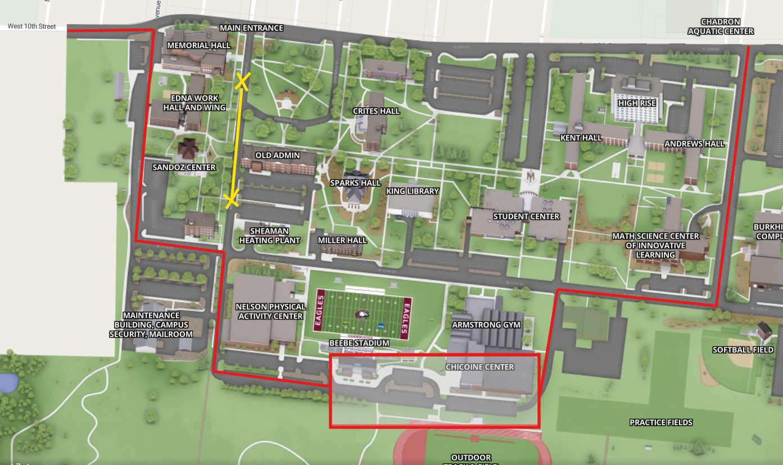

**Scottsbluff Area College Fair**

1:30PM- 3:00PM (MST)

Location: Western Nebraska Community College- Cougar Palace Gym

Address: 1601 E. 27th Street Scottsbluff, NE  69361

Contact: Jolene Martin [jolene@wncc.edu](mailto:jolene@wncc.edu), Connagher Stumpff [connagher@wncc.edu](mailto:connagher@wncc.edu) 308-635-6010

Details: There are no designated parking areas. You will have three entrances to choose from.

Main Entrance in the front of the school, this will allow you quick and direct access into Cougar Palace. Door 6 on the west side of the building; once through the door, you will walk down the stairs into Cougar Palace. Performing Arts entrance, once inside, you will head towards the main entrance and into Cougar Palace. We will have water and light snacks for you. Buddy's Books & Bistro will also be open for coffee, cold drinks and food options. Also, here are some local favorites if you want to grab a bite before or after the fair.

**Scottsbluff Eats & Treats**

Backaracks Bar and Grill, Buffalo Wild Wings, Express Cappuccino and Company – Coffeehouse & Cafe, Breakfast & Lunch, Flyover Brewing Company, Jax Gourmet Coffee & Snow, Qdoba, Sam & Louie’s Pizza, Starbucks (located in Target), Tacos Mexico, Which Which, Yoshi’s Frozen Yogurt *…there are many more, these are just a few favorites.*

High Schools invited: Banner County, Bayard, Bridgeport, Choices, Gering, Kimball, Minatare, Mitchell, Morrill, Reconnect, Scottsbluff, and Vaults

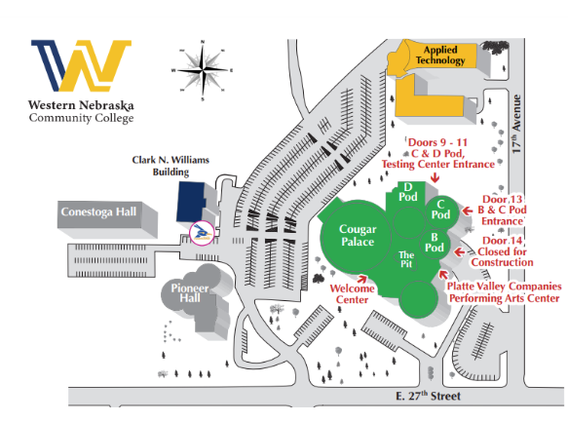

**Weekly Social!**

Date: Tuesday, September 9th

Town: Sidney

Location: The Rock Sports Bar & Grill

Time: 6:30pm

This year we are going to set up weekly socials for everyone to meet up during the week, grab a bite, unwind from travel and socialize and watch “the game”. This will not be a NACRAO sponsored event so come and go as you please. We look forward to seeing you all there!

**Wednesday, September 10th**

**Sidney Area College Fair**

9:00AM- 10:00AM (MST)

Location: Sidney High School

Address: 1100 19th Avenue, Sidney NE 69162

Host Site Contact: Kelle Dillehay; 308-254-5893 ext: 305; [kelle.dillehay@raidermail.org](mailto:kelle.dillehay@raidermail.org)

Details: The College Fair will be in the main gym.

High Schools Invited: Creek Valley High School, Kimball High School, Leyton High School, Potter Dix High School.

**Ogallala Area College Fair**

1:30 to 2:30PM (MST)

Location: Ogallala High School

Address: 602 East 6th Street, Ogallala, NE 69153

Contact Information: Jennifer Bekke, 308-284-4029, [jenniferbekke@opsd.org](mailto:jenniferbekke@opsd.org)

Entrance Instructions: Parking will be in the big parking lot on the west side of the building or on the street in front of the school. Enter in through the office doors on the south side of the building. Fair will be held in the gym and a host will be there to greet and show you where to go. Set up time: 12:15 – 1:00

High Schools Invited: Chase County Schools, Garden County High School, Paxton Consolidated Schools, Perkins County Schools, South Platte Public Schools.

**Thursday, September 11th**

**North Platte Area College Fair**

8:30 to 10:00AM (CST)

Location: North Platte High School

Address: 1220 W 2nd Street, North Platte, NE 69101

Host Site Contact: Amie Albrecht, [aalbrecht@nppsd.org](mailto:aalbrecht@nppsd.org), Sky Schute, sschute@nppsd.org

719.760.9615: Amie’s cell

Representatives may park in the lot in front of the school and can enter through the main doors

of the building. Reps may begin setting up any time after 7:30 am. Reps must bring their driver’s license to be admitted to the building. You will have to scan to enter the building. Please plan accordingly as we only have 2 computers to check people in.

High Schools Invited: Brady, Hershey, Maxwell, Maywood, Medicine Valley North Platte, St. Patrick’s, Stapleton, Sutherland, Wallace.

**Chase County Area College Fair**

1:00PM- 2:30PM (MST)

Location: Chase County High School

School Address: 520 East 9th Street Imperial, NE 69033

Host Site Contact Information: Jaclyn Paisley, 308-882-4304

Details: All individuals attending the college fair will need to park in the large parking lot located east of the Auxiliary Gym door. Buses may drop students off at the door and park on the east side of the parking lot. The Auxiliary Gym will have tables set up for each college/representative. Restrooms will be located near the Auxiliary Gym.

High Schools Invited: Dundy County, Hayes Center, Hitchcock County, Maywood, McCook, Medicine Valley, Southwest (Bartley), Wauneta-Palisade.

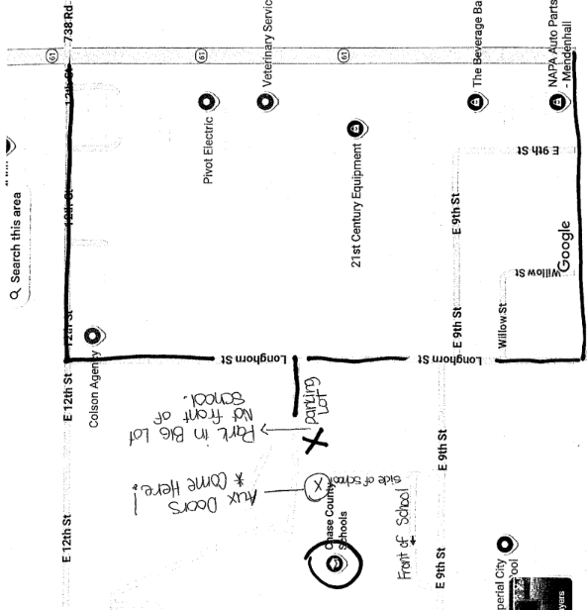

**Friday, September 12th**

**Lexington Area College Fair**

9:00AM- 10:30AM (CST)

Location: Lexington High School

Address: 1400 Minuteman Dr, Lexington, NE 68850

Host Site Contact: Contact: Joel Lemus 308-324-1272 [joel.lemus@lexschools.org](mailto:joel.lemus@lexschools.org), Cyndi Hoyt 308-324-1269 [cyndi.hoyt@lexschools.org](mailto:cyndi.hoyt@lexschools.org), Reyna Clouse 308-324-1261 reyna.clouse@lexschools.org

Details: Parking will be available on the south side of the school just off of 13th Street. There is a four-way traffic light on 13th Street and Adams Street. Just to the west of that is our school. We will have parking ‘coned off’ for our visitors and our Kearney Bound scholars will be there to greet you and let you through our doors to get to the gymnasium.

Gym space: We will have our college fair in the larger West Gym. Access to restrooms will be nearby.

High Schools Invited: Cozad, Elwood, Eustis-Farnam, Gothenburg, Lexington, Overton, Sumner/Eddyville/Miller

