Hello!

The following is information for each NACRAO College Fair scheduled the week of **September 15th to September 19th.** *These emails will be going out to all NACRAO Reps, if your college did not register for these fairs, please ignore as it is to assure everyone receives the information needed for travel!*Please forward this information to any representatives who will be attending these events. If you have any questions about an event, or will no longer be able to attend an event, please contact the host site directly (contact information is below).

*As a reminder we are using [StriveScan](https://www.strivescan.com/) as our college fair scanning app! Be sure to purchase a per fair you wish to attend (only one credit needed per school). If you're not familiar with StriveScan, [you can watch a quick, 2-minute video on how it works](https://urldefense.com/v3/__https:/www.strivescan.com/*intro__;Iw!!I6-y8lpfja43!uRp08Esb-nX-rHwEJ429Oqv-AwriQbasJ48XrKdbEx20y75Btm2fbheddH7Lo1MdwWyXiuZJB_Z0-olv7Xf5$).

**Monday, September 15th**

**Beatrice Area College Fair**

**Time: 8:30am to 10:30am**

**Location: Southeast Community College, Beatrice Campus – Truman Center**

Address: 4771 W Scott Rd, Beatrice NE 68310

Host Site Contact: Lindsay Wallin, 720-206-9627, [lwallin@southeast.edu](mailto:lwallin@southeast.edu)

Details: Reps are welcome to start setting up by 8:00am. There will be refreshments available for your enjoyment. The event is held in the Truman Center (Blue start). Tables are not assigned. Parking is in the lot marked with the yellow triangle.

High Schools Invited: Beatrice High School, Bruning-Davenport High School, Deshler High School, Diller-Odell Community Schools, Fairbury Jr-Sr High School, Freeman Public Schools, Lewiston Consolidated Schools, Meridian High School, Pawnee City Public Schools, Southern School District, Sterling High School, Tri-County Public Schools, Wilber-Clatonia Public Schools

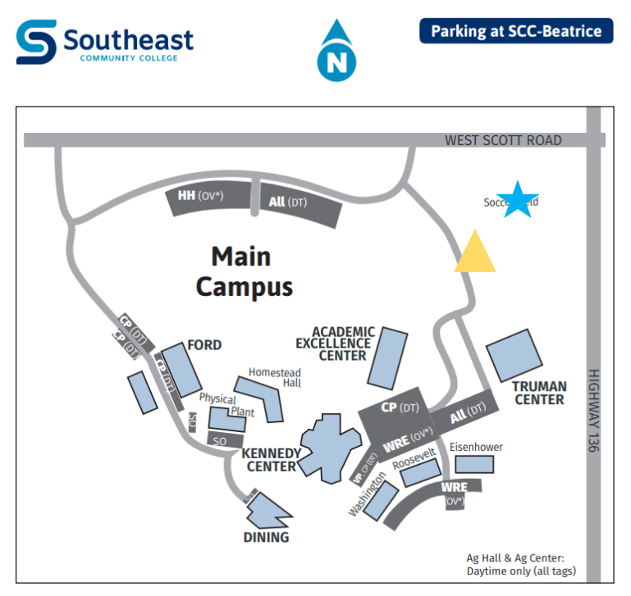

**Auburn Area College Fair**

**Time: 1:00pm to 2:30pm**

**Location: Auburn High School**

Address: 1829 Central Ave, Auburn NE 68305

Host Site Contact: Sara Toedman, [sara.toedman@apsbulldogs.org](mailto:sara.toedman@apsbulldogs.org)

Details: Upon arrival at Auburn High School, please park in any available spaces toward the north end of campus. Enter the building through the set of four doors facing north (Highway 136 side). Greeters will be stationed at this entrance to assist you in carrying items and to guide you to your assigned table.

High Schools Invited: Conestoga Public Schools, Falls City High School, Humboldt-Table Rock-Steinauer Public Schools, Johnson-Brock High School, Lourdes Central High School

Nebraska City High School, Pawnee City Public School, Sacred Heart High School, Syracuse-Dunbar-Avoca High School.

**Tuesday, September 16th**

**Fremont Area College Fair**

**Time: 9:00am to 10:30am**

**Location: Fremont High School**

Address: 1750 N Lincoln Ave, Fremont, NE 68025

Host Site Contact: Rachel Fredrickson, [Rachel.fredrickson@fpsmail.org](mailto:Rachel.fredrickson@fpsmail.org)

Details: When arriving at Fremont High School, please park in the north parking lot. The map shows where you can enter the parking lot and has designated entrances for the colleges and businesses that will be at the event. Colleges will enter the side doors of the Bahe Gym.

High Schools Invited: Archbishop Bergan Catholic School, Arlington Public Schools, Bennington High School, Bishop Neumann High School, Blair High School, Cedar Bluffs High School, DC West High School, Guardian Angels Central Catholic High School, Howells-Dodge Consolidated School, Logan View Public Schools, Lyons-Decator Northeast School, Mead Public Schools, North Bend Central High School, Oakland-Craig Public Schools, Scribner-Snyder Jr-Sr High School, Tekamah-Herman Schools, Wahoo Public Schools.

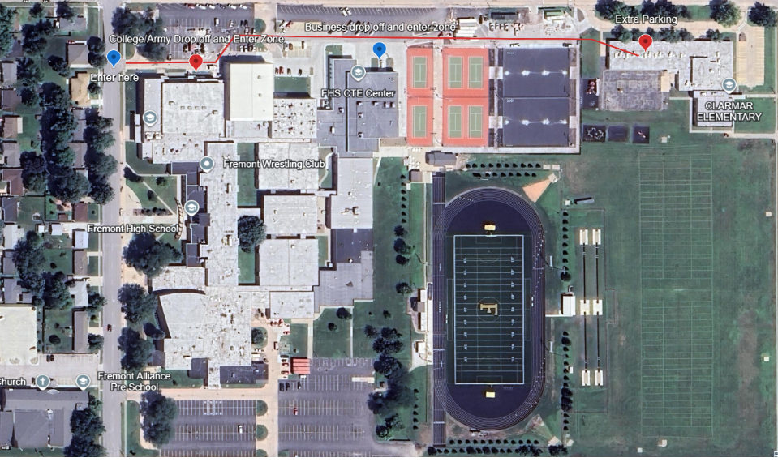

**Columbus Area College Fair**

**Time: 1:00pm to 3:00pm**

**Location: Central Community College – Columbus Campus, Raider Fieldhouse**

Address: 4500 63rd St, Columbus NE 68601

Host Site Contact: Austin Patzel – Cell: 402-625-5725, lora Hastreiter – Cell: 402-910-1949

Details: The Fieldhouse is number 8 on the attached map. Recruiters can come up 33rd or 48th Ave and park in either lot. Please enter through the south doors and stop at the check-in table. Estimating 150 students. Light appetizers and drinks will be provided for college reps! Including little smokies, fried ravioli, meet & cheese tray and grab-and-go snacks as well!

High Schools Invited: Archangels Catholic High School, Aquinas Catholic, Boone Central High School, Clarkson Public Schools, Columbus High School, David City Public Schools, East Butler Public Schools, Howells-Dodge Consolidated School, Humphrey Jr-Sr High School, Lakeview Community Schools, Leigh Community Schools, Lindsay Academy, Newman Grove High School, Riverside High School, Schuyler Central High School, Scotus Central Catholic Jr-Sr High School, Shelby-Rising City Public Schools, St. Edward Public Schools, Twin River Public Schools

**Wednesday, September 17th**

**Bellevue Area College Fair**

**Time: 8:00am to 10:00am**

**Location: Lied Activity Center**

Address: 2700 Arboretum Dr., Bellevue, NE. 68005

Host Site Contact: Randy Schultz (402) 213-8824, [randall.schultz@bpsne.net](mailto:randall.schultz@bpsne.net) or

Kathie Britten (402) 350-7216, kathie.britten@bpsne.net

Details: Set up begins at 7:30am. Table size: 6ft-8ft rectangle table

# of students: 300+. **Lied Center Parking** (see red rectangle on map)– Park in the West/Southwest area of the parking lot. Bellevue Public School Buses will be dropping off students at the main doors and picking them up using the rear exit doors. **Entrance**- Enter through the main doors to the Lied Center.  From there, someone will show you to your reserved table.

High Schools Invited: Bellevue East High, Bellevue West High

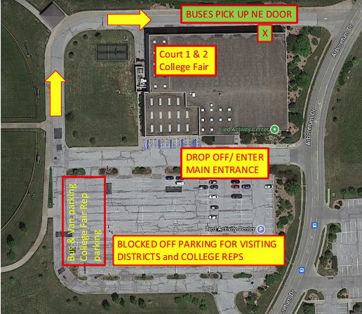

**York Area College Fair**

**Time: 12:30pm to 2:00pm**

**Location: York High School**

Address: 1005 Duke Dr, York NE 68467

Host Site Contact: Tami Wegener, (402) 362-6655 Ext. 224, [tami.wegener@yorkdukes.org](mailto:tami.wegener@yorkdukes.org)

Details: The College Fair will be located in the main gym on the gym deck.  Representatives may park in the southeast lot of the high school. You may enter through the east doors on the east side of the building located by the big York Duke head.

High Schools Invited: Aurora, Centennial, Cross County, Exeter-Milligan-Friend, Fillmore Central, Hampton, Heartland, High Plains, McCool Junction, Nebraska Lutheran, Osceola, Shickley, Thayer Central, York Enrichment Center.

**Thursday, September 18th**

**Norfolk Area College Fair**

**Time: 9:00am to 11:00am**

**Location: Northeast Community College- Cox Activities Center**

Address: 801 E Benjamin Ave, Norfolk NE

Host Site Contact: Joni Roush; 402-750-0392; joni@northeast.edu

Details: Representatives may park in the lot south of the Cox Activities Center and can enter through the doors on the south side of the building (see map). Reps may begin setting up any time after 8:00am.  Coffee, Water and breakfast items will be provided to reps—there is also a Starbucks in the Union.

High Schools Invited: Battle Creek, Lutheran High Northeast, Madison, Norfolk Catholic, Norfolk High, Osmond, Pender, Pierce, Plainview, Randolph, Stanton, Winside.  Approximately 640 students are expected to attend.

**Knox/Cedar Area College Fair**

**Time: 1:30pm to 3:00pm**

**Location: Bloomfield High School**

Address: 311 E. Benton Bloomfield, NE 68718

Host Site Contact: Angie Guenther [aguenther@blfdbees.org](mailto:aguenther@blfdbees.org) 402-373-4800

Details: Please park in the parking lot right to the west of the high school building (we consider this our gym parking). We will have our students park in a different location that day. Enter in the west doors. Sept up time will be from 12:30 to 1:15 so as to have all college reps ready by 1:30pm.

High Schools Invited: Bloomfield Community Schools, Cedar Catholic Senior High School, Creighton Community High School, Crofton Community Schools, Hartington-Newcastle Public Schools, Laurel-Concord-Coleridge Schools, Niobrara Public Schools, Randolph Public Schools, Santee Community School, Verdigre High School, Wausa Public School, Wynot High School

**Weekly Social**

Location: The Wheelhouse Bar & Grill

Address: 4501 Southern Hills Drive #1 Sioux City IA

Time: 6:30pm

**Friday, September 19th**

**S. Sioux City Area College Fair**

**Time: 8:30am to 10:30am**

**Location: South Sioux City High School**

Address:  3301 G. Street, South Sioux City, NE 68776

Host Site Contact: Danielle Panowicz, School Counselor, So. Sioux City High School, [danielle.panowicz@ssccards.org](mailto:danielle.panowicz@ssccards.org), 402-494-2433

Details: Parking will be in the G Street parking lot, entry will be on the G Street side of the building, door 11. See map.

High Schools Invited: Allen Consolidated Schools, Emerson-Hubbard High School, Homer Community Schools, Lyons-Decatur Northeast School, Pender Public School, Ponca Public School, UmonHon Nation High School, Wakefield Community School, Walthill Public School, Winnebago Public School

