Hello!

The following is information for each NACRAO College Fair scheduled the week of **September 22nd through September 26th.** *These emails will be going out to all NACRAO Reps, if your college did not register for these fairs, please ignore as it is to assure everyone receives the information needed for travel!*Please forward this information to any representatives who will be attending these events. If you have any questions about an event, or will no longer be able to attend an event, please contact the host site directly (contact information is below).

*As a reminder we are using [StriveScan](https://www.strivescan.com/) as our college fair scanning app! Be sure to purchase a per fair you wish to attend (only one credit needed per school). If you're not familiar with StriveScan, [you can watch a quick, 2-minute video on how it works](https://urldefense.com/v3/__https:/www.strivescan.com/*intro__;Iw!!I6-y8lpfja43!uRp08Esb-nX-rHwEJ429Oqv-AwriQbasJ48XrKdbEx20y75Btm2fbheddH7Lo1MdwWyXiuZJB_Z0-olv7Xf5$).

**Monday, September 22nd**

**Omaha South College Fair**

**Time: 8:30 am to 10:30am**

**Location: Omaha South High School**

Address: 4519 S. 24th St., Omaha, Ne. 68107

Host Site Contact: Jennifer Buelt 531-299-8583 [jennifer.buelt@ops.org](mailto:jennifer.buelt@ops.org)

Details: Jacobo’s Parking Lot on the NE corner of 24th and L Street. The grocery store is closed on Mondays, we have permission from the owners to use the lot. South High Gym is just North along 24th St. Enter through the Gym entrance. Along 24th street door #21. JROTC greeters will be at the door to assist starting at 7:45

High Schools Invited: Omaha Southeast Community College 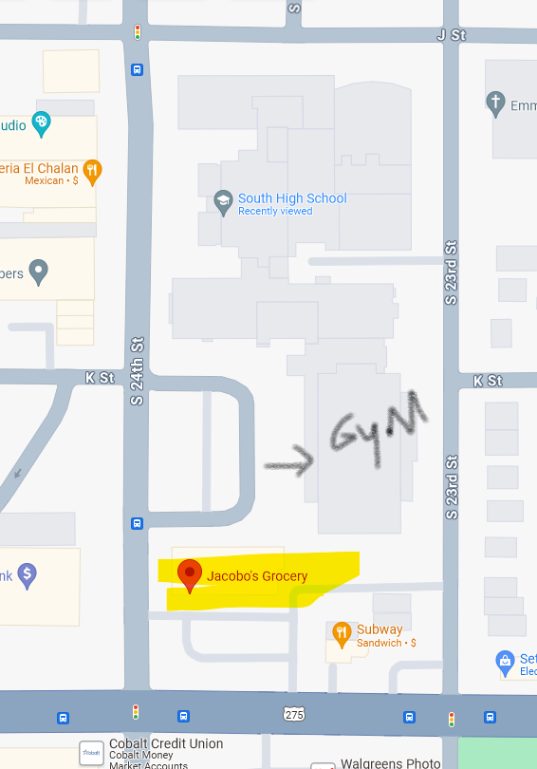

**Buena Vista College Fair**

**Time: 1:30pm to 3:00pm**

**Location: Buena Vista High School**

Address: 5616 L Street, Omaha 68117

Host Site Contact: Kristi Ryan - 531-299-6858, [Kristin.ryan@ops.org](mailto:Kristin.ryan@ops.org)

Details: Park in the South Parking Lot, front of the school, off of L Street. Enter through the Main doors and sign in as a visitor in the main office. We will have someone there to greet you and escort you to the fair area. Tables will be ready at 1:15 p.m. in what we are calling the Main Gym Loop.

High Schools Invited: Omaha Buena Vista High School

**Tuesday, September 23rd**

**Omaha North College Fair**

**Time: 10:00am to 12:00pm**

**Location: Omaha North High School**

Address: 4410 N 36th St, Omaha, NE 68111

Host Site Contact:  Kevin Custard – (531)299-7207 – [kevin.custard@ops.org](mailto:kevin.custard@ops.org)

Details: Due to the construction of our football field, we do not have access the YMCA parking lot as we have in the past.  We have 3 parking lots on the east side (36th St) of the school.  Two are available by the entrance of the school.  A third smaller lot is available slightly past the main parking lots by our track.  Parking may be limited in these spots and you may need to park on the streets within the neighborhood. We will open at 9:15 p.m. for you to begin setup. Tables are not assigned or marked, so please bring appropriate signage.  Tables are 8’ tables and each will have two chairs.

High Schools Invited: Omaha North High School

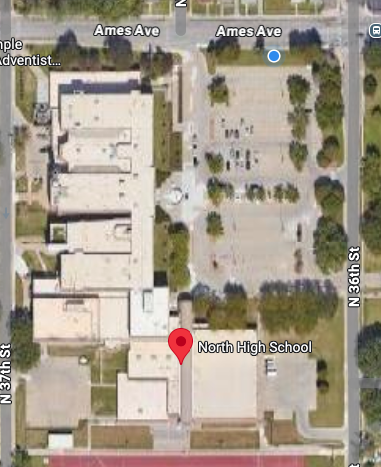

**Omaha Burke College Fair**

**Time: 1:00pm to 3:00pm**

**Location: Omaha Burke High School**

Address: 12200 Burke St, Omaha NE 68154

Host Site Contact: Nadine Reyes [Nadine.reyes@ops.org](mailto:Nadine.reyes@ops.org)

Details: Est. number of **Juniors** attending (430).  Est Number of **Seniors** attending (430). **Lunch will be provided for Reps at Burke starting at Noon**. Please park in the west lot nearest the activity entrance in the yellow highlighted area. The blue highlighted area is where students will be waiting to assist with unloading if necessary.Enter in the Activity Entrance.

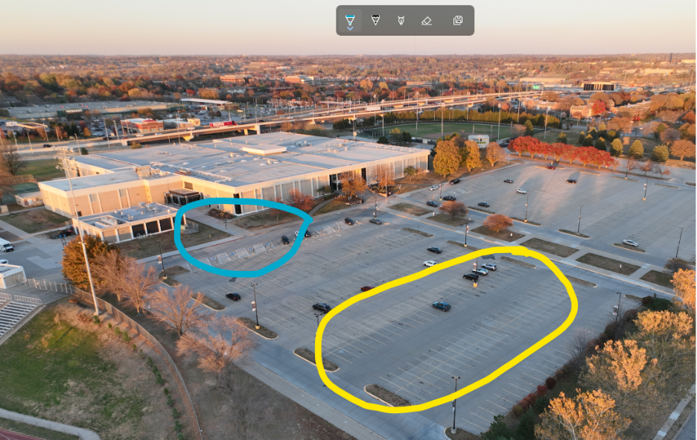

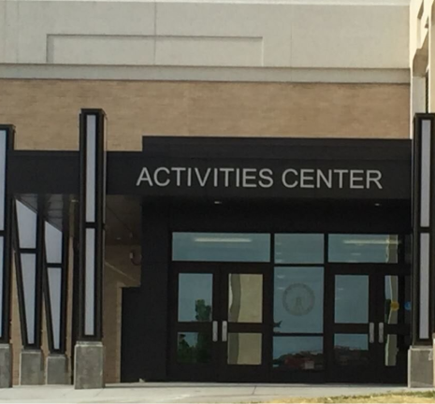

High Schools Invited: Omaha Burke High School

**Gretna Area College Fair**

**Time: 5:00pm to 6:30pm**

**Location: Gretna High School**

Address: 11335 S. 204th Street, Gretna, NE 68028

Host Site Contact: Melissa Ryan, School Counselor, Gretna High School, [mryan@gpsne.org](mailto:mryan@gpsne.org), 402.660.4567

Details: Parking will be in the front lots. Entry will be through the Main Entrance

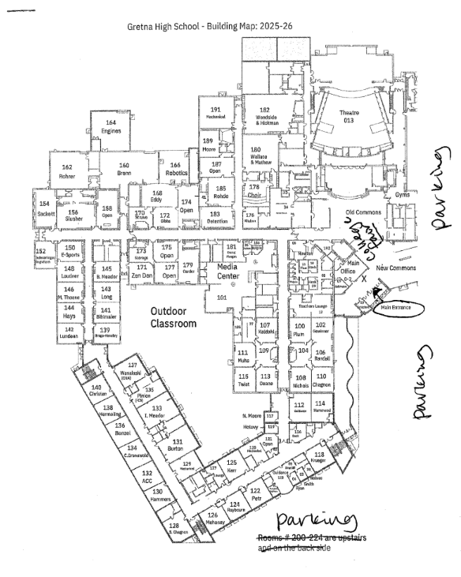

High Schools Invited: Gretna East High School, Ashland – Greenwood High School, Louisville High School, Mead High School, Platteview High School, Plattmouth High School, Weeping Water High School, Yutan High School

**Wednesday, September 24th**

**Omaha Bryan College Fair**

**Time: 8:30am to 10:30am**

**Location: Omaha Bryan High School**

Address: 4700 Giles Rd, Omaha 68157

Host Site Contact: Sheila Lahmann - 531-299-6666, sheila.lahmann@ops.org or, ***for day of*** questions for the 25-26 school year, please contact  Danyel Kobes – 531-299-5833, [danyel.kobes@ops.org](mailto:danyel.kobes@ops.org)

Details: Park in the Football Parking Lot, between Bryan High and Bryan Middle. You will enter off of Giles Road at approximately 44th St. There will be a shuttle to drive you and your materials down to the Aux Gym Entrance. Tables will be ready at 7:45 a.m. in the Auditorium.

High Schools Invited: Omaha Bryan High School

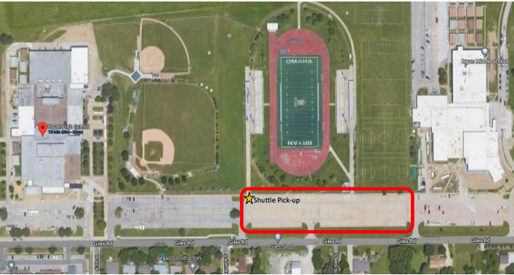

**Omaha Westview College Fair**

**Time: 1:30pm to 3:00pm**

**Location: Omaha Westview High School**

Address: 15800 Summit Plz, Bennington, NE 68007

Host Site Contact: Alyssa Krogstrand - [alyssa.krogstrand@ops.org](mailto:alyssa.krogstrand@ops.org); 531­-299-3937

Details: We will have the gym set up at 1:00 for reps. Please check in at the front office. Parking will be in the south senior lot. Please do not park in a painted spot.

High Schools Invited: Omaha Westview High School

**Weekly Social!!**

Location: DJ’s Dugout Sparts Bar – Aksarben Village

Date: Wednesday, September 24th

Address: 2102 S 67th Omaha NE

Time: 6:30pm

**Thursday, September 25th**

**Omaha Central College Fair**

**Time: 8:30AM- 10:30AM**

**Location: Central High School**

Address: 124 N 20th St, Omaha, NE 68102

Host Site Contact: Sheri Harrach, [sheri.harrach@ops.org](mailto:sheri.harrach@ops.org)

Details: The blue circle is parking that is available.  This is the Joselyn Art Museum’s parking lot.  You will come in from 24th and James Fous Ave.  You will turn right into the lot prior to entering the Central HS parking lot.  We are asking that you park along the back fence line and enter Central’s property through the gate.  This will put you close to the main entrance. Additional parking: **#1 -** You may park in the Staff Parking off of 24th and James Fous Ave.; **# 2 -** the Coach’s Lot off of 20th St; or the **#3 -** Senior Lot off of 19th and Dodge.  Please note that 20th Street, Dodge Street and James Fous Ave. are one-way streets. The Staff Parking - #1 is off of 24th and James Fous Ave. You will need to enter the Coach’s Lot - #2 from 20th St. You will need to enter the senior lot - #3 from east of 20th Street so you will need to turn onto Dodge St. from 18th or 19th St. depending on the direction you are coming from.

High Schools Invited: Omaha Central High School

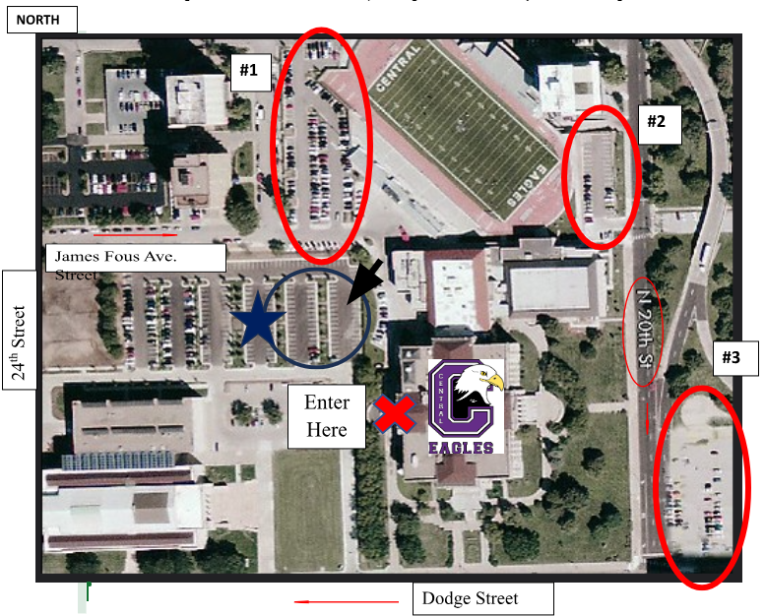

**Omaha Benson College Fair**

**Time: 1:00pm to 2:00pm**

**Location: Omaha Benson High School**

Address: 5120 Maple Street, Omaha, NE 68104

Host Site Contact: Andrea Brown – (531)299-8043 – [andrea.brown@ops.org](mailto:andrea.brown@ops.org), (Heather Cardinale - counseling secretary - (531)299-7994

Details: Parking (see red circle on map)– Park in the **north** lot.  The south lot is on Maple Street.  No entry on this side of the building.  The north lot is in between Maple and Bedford Street.  Benson High is south of the lot, Monroe Middle is north of the lot, and the football field is east of the lot.  A parking pass for this fair is located at the end of this document. Entrance (see green circle on map) – Enter through the main entrance.  These doors are on the north side of the school, south of the parking lot being used.  There should be counselors at the door to help direct you to the new gym.  There is also a security guard stationed at this door, so if a counselor is not there, please just let them know you are at Benson for the college fair in the new gym.  The new gym is just to the west/right when you enter through the main entrance. Set-Up Time – We will begin setting up tables at 11:30 a.m.  College/military reps can start arriving at 12:00 p.m.  They may choose a table.  Tables will not be assigned or marked, so please bring appropriate signage.  Tables are 6’ or 8’ tables and each will have one chair.  There will be extra chairs available if additional are needed.

High Schools Invited: Omaha Benson High School

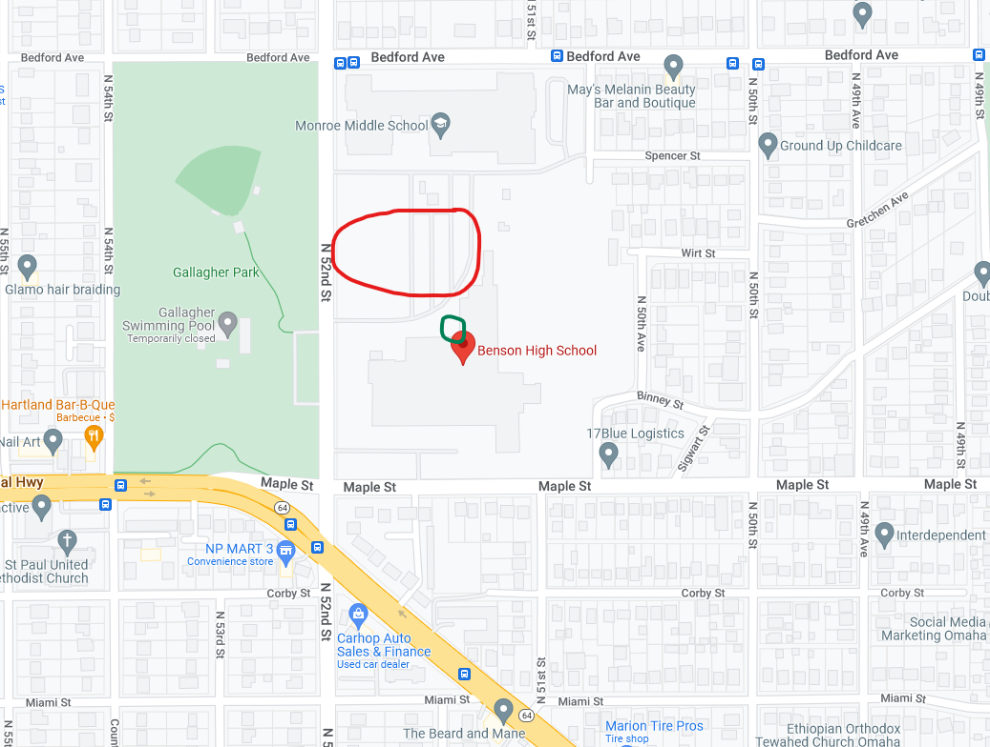

**Friday, September 26th**

**Omaha Northwest College Fair**

**Time: 8:00am to 10:00am**

**Location: Omaha Northwest High School**

Address: 8204 Crown Point Ave, Omaha NE 68134

Host Site Contact: Jennifer Rotherham [Jennifer.rotherham@ops.org](mailto:Jennifer.rotherham@ops.org) 531-299-9686

Details: Arrival Time: Reps may begin arriving as early as 7:10 AM. Peak Student Arrival: Please note that student arrival tends to be busiest between 7:20 and 7:40 AM. Please park in the West lot. Enter the building on the South side through the main entrance — this is the large

glass entryway facing Crown Point Avenue. Upon arrival, please check in with security. Our student ambassadors will be available to guide you to the gymnasium. Each representative will be provided with one table and two chairs. We are excited to share that all 1,400 students will be invited to attend the event throughout the day.

High Schools Invited: Omaha Northwest College Fair

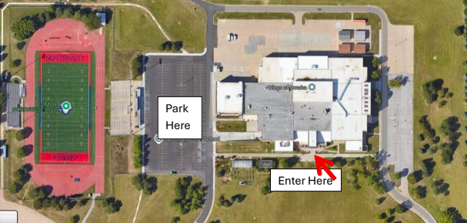

**Omaha Benson College Fair Parking Pass**

