Hello!

The following is information for each NACRAO College Fair scheduled the week of September 21st through September 24th. These emails will be going out to all NACRAO Reps, if your college did not register for these fairs, please ignore as it is to assure everyone receives the information needed for travel! Please forward this information to any representatives who will be attending these events. If you have any questions about an event, or will no longer be able to attend an event, please contact the host site directly (contact information is below).

*As a reminder we are using StriveScan as our college fair scanning app! Be sure to purchase a per fair you wish to attend (only one credit needed per school). If you're not familiar with StriveScan, you can watch a quick, 2-minute video on how it works.

Monday, September 21st
Beatrice Area College Fair
Time: 8:30am to 10:30am
Location: Southeast Community College, Beatrice Campus – Truman Center
Address: 4771 W Scott Rd, Beatrice NE 68310
Host Site Contact: Emily Wendland, ewendland@southeast.edu
Details: Reps are welcome to start setting up by 8am. There will be refreshments available (coffee, water, bagels, fruit) for your enjoyment! The event is held in the Truman Center (blue star). Tables are not assigned. Parking is in the lot marked with the yellow triangle.

High Schools Invited: Beatrice High School, Bruning-Davenport High School, Deshler High School, Diller-Odell Community Schools, Fairbury Jr-Sr High School, Freeman Public Schools, Lewiston Consolidated Schools, Meridian High School, Pawnee City Public Schools, Southern School District, Sterling High School, Tri-County Public Schools, Wilber-Clatonia Public Schools
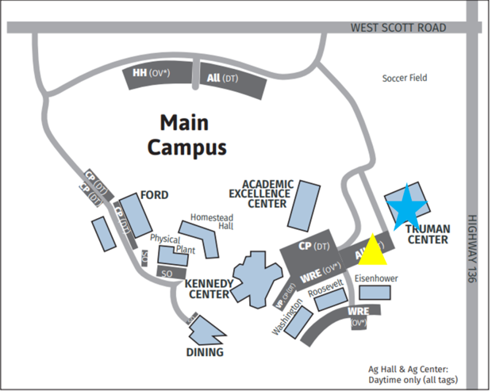

Auburn Area College Fair
Time: 1:00pm to 2:30pm
Location: Auburn High School
Address: 1829 Central Ave, Auburn NE 68305
Host Site Contact: Amy Wynn, 402-274-4328 amy.wynn@apsbulldogs.org. Sara Toedman, 402-274-4328 sara.toedman@apsbulldogs.org
Details: Upon arrival at Auburn High School, please park in any available spaces toward the north end of campus. Enter the building through the set of four doors facing north (Highway 136 side). Greeters will be stationed at this entrance to assist you in carrying items and to guide you to your assigned table.

High Schools Invited: Conestoga Public Schools, Falls City High School, Humboldt-Table Rock-Steinauer Public Schools, Johnson-Brock High School, Lourdes Central High School
Nebraska City High School, Pawnee City Public School, Sacred Heart High School, Syracuse-Dunbar-Avoca High School.

Tuesday, September 22nd
York Area College Fair
Time: 9:00 to 10:30am
Location: York High School
Address: 1005 Duke Dr, York NE 68467
Host Site Contact: Tami Wegener, (402) 362-6655 Ext. 224, tami.wegener@yorkdukes.org
Details: The College Fair will be located in the main gym on the gym deck. Representatives may park in the southeast lot of the high school. You may enter through the east doors on the east side of the building located by the big York Duke head.

High Schools Invited: Aurora, Centennial, Cross County, Exeter-Milligan-Friend, Fillmore Central, Hampton, Heartland, High Plains, McCool Junction, Nebraska Lutheran, Osceola, Shickley, Thayer Central, York Enrichment Center.

Columbus Area College Fair
Time: 12:30 to 2:30pm
Location: Columbus Community Hospital Fieldhouse
Address: 3912 38th St Ste F, Columbus, NE 68601
Host Site Contact: Austin Patzel – Cell: 402-625-5725 austinpatzel@cccneb.edu
Details: Reps can start setting up at 12:00pm. The staff has asked that reps either park in the north end of the East Lot or the North Lot and walk around the side. This place is also a medical facility so please try to park in the green highlighted areas. The yellow star is the glass sliding doors that will take you to the gym. There will be plenty of signs to guide you but we will also have a welcoming table inside the sliding doors. We will have drinks and snacks available.

High Schools Invited: Archangels Catholic High School, Aquinas Catholic, Boone Central High School, Clarkson Public Schools, Columbus High School, David City Public Schools, East Butler Public Schools, Howells-Dodge Consolidated School, Humphrey Jr-Sr High School, Lakeview Community Schools, Leigh Community Schools, Lindsay Academy, Newman Grove High School, Riverside High School, Schuyler Central High School, Scotus Central Catholic Jr-Sr High School, Shelby-Rising City Public Schools, St. Edward Public Schools, Twin River Public Schools
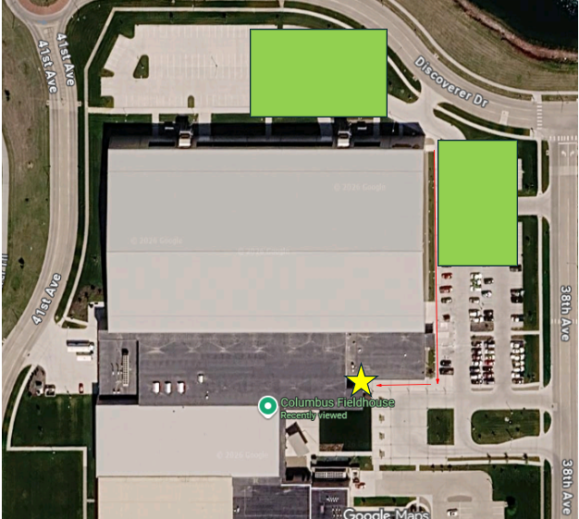

Wednesday, September 23rd
South Sioux City Area College Fair
Time: 8:30 to 10:30am
Location: South Sioux City High School
Address: 3301 G. Street, South Sioux City, NE 68776
Host Site Contact: Danielle Panowicz, School Counselor, So. Sioux City High School, danielle.panowicz@ssccards.org, 402-494-2433
Details: Parking will be in the G Street parking lot, entry will be on the G Street side of the building, door 11. See map. Water, coffee and breakfast pastries will be provided.

High Schools Invited: Allen Consolidated Schools, Emerson-Hubbard High School, Homer Community Schools, Lyons-Decatur Northeast School, Pender Public School, Ponca Public School, UmonHon Nation High School, Wakefield Community School, Walthill Public School, Winnebago Public School
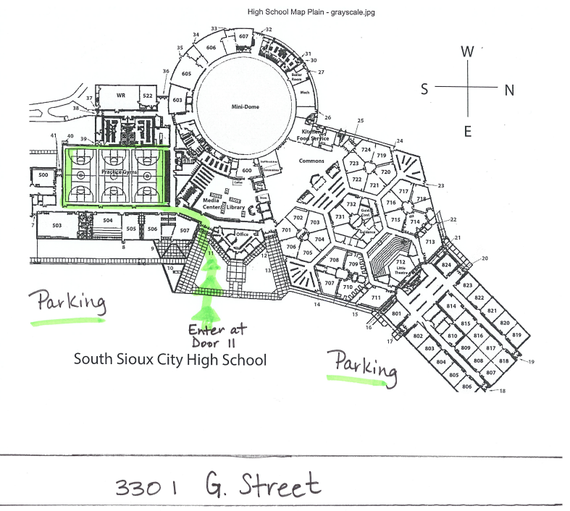

Knox/Cedar Area College Fair
Time: 1:00 to 2:30pm
Location: Bloomfield High School
Address: 311 E. Benton Bloomfield, NE 68718
Host Site Contact: Angie Guenther aguenther@blfdbees.org 402-373-4800
Details: Please park in the parking lot right to the west of the high school building (we consider this our gym parking). We will have our students park in a different location that day. Enter in the west doors. Sept up time will be from 12:00 to 12:45pm so as to have all college reps ready by 1:00pm. We plan on having student helpers greet you at the gym entrances and helping you to your table.

High Schools Invited: Bloomfield Community Schools, Cedar Catholic Senior High School, Creighton Community High School, Crofton Community Schools, Hartington-Newcastle Public Schools, Laurel-Concord-Coleridge Schools, Niobrara Public Schools, Randolph Public Schools, Santee Community School, Verdigre High School, Wausa Public School, Wynot High School.

Weekly Social!
Location: Divots Downtown
Address: 206 W Norfolk Ave, Norfolk NE 68701
Time: 6:00pm

Thursday, September 24th
Norfolk Area College Fair
Time: 8:30 to 10:30am
Location: Northeast Community College- Lifelong Learning Center
Address: 801 E Benjamin Ave, Norfolk NE
Host Site Contact: Joni Roush; 402-750-0392; joni@northeast.edu
Details: The Cox Activities Center (Gym) is under construction, so the fair will be held in the Lifelong Learning Center (LLC) this year. Representatives may park in the lot between the LLC and Cox Activities Center and can enter through the doors on the north side of the LLC (see map). Reps may begin setting up any time after 7:45am. Coffee, Water and breakfast items will be provided to reps—there is also a Starbucks in the Union.

High schools Attending: Battle Creek, Lutheran High Northeast, Madison, Norfolk Catholic, Norfolk High, Osmond, Pender, Pierce, Plainview, Randolph, Stanton, Winside. Approximately 700 students are expected to attend.

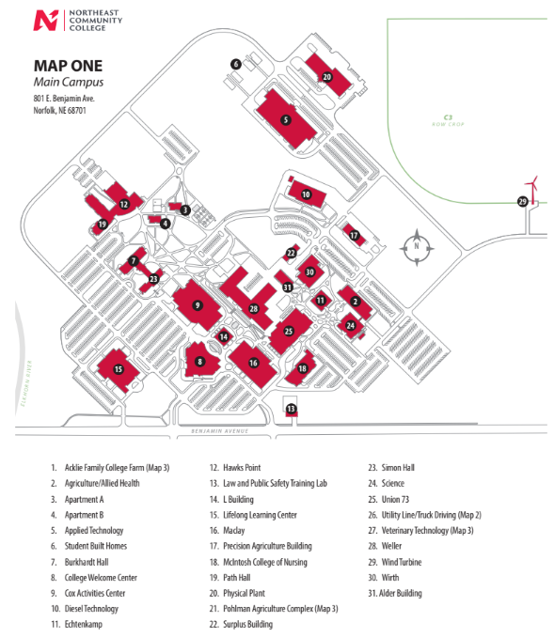

O’Neill Area College Fair
Time: 1:00 to 2:30pm
Location: O’Neill High School
Address: 540 E Hynes Ave, O’Neill NE
Host Contact: Cole Hilker; 402-335-2667; colehilker@oneillschools.org
Details: Parking for the reps can be in the center parking, between the Activity entrance and Main entrance. If that is filled, they can also parallel park on the north side of the football field. If that is full, it’s a walk but can park on the south side of the football field on the grass.

High Schools Invited: Boyd County Public Schools, Chambers High School, St. Mary's Catholic Schools, Stuart High School, Summerland Public School, West Holt Public School

