Hello!

The following is information for each NACRAO College Fair scheduled the week of October 5th through October 9th. Please forward this information to any representatives who will be attending these events. If you have any questions about an event, or will no longer be able to attend an event, please contact the host site directly (contact information is below).

As a reminder, please review College Fair Guidelines for College/University/Military Participation before attending fairs to assure you are in compliance.

Monday October 5th
Lincoln Southeast College Fair
Time: 9:00 to 10:30am
Location: Lincoln Southeast High School
School Address: 2930 S. 37th St. Lincoln, NE 68506
Host Site Contact: Kelley Winter; (402) 436-1304 opt. 3, kwinter@lps.org
Details: Representatives may begin setting up at 8:15 AM. Drop off materials/equipment with LSE Student Ambassadors at 37th & Otoe Street
(Door 6 – North of Main Entrance). Student Ambassadors will assist in carrying materials to your assigned table. After unloading materials, please proceed to park your vehicle. Refer to the attached map below for parking and entrance locations. Use street parking on Otoe, Pawnee, or Melrose Ave. Note: You will not be ticketed despite posted “No Parking” signage. After parking, enter through Door 6 (John Prasch Activities Center), located at 37th & Otoe. Students/staff will be stationed at the entrance to direct you to your table.

High Schools Invited: Southeast High School. Juniors: 9:00 – 9:45 AM. Seniors: 9:45 – 10:30 AM. Attendance: Approximately 300+ Juniors & Senior students are expected.
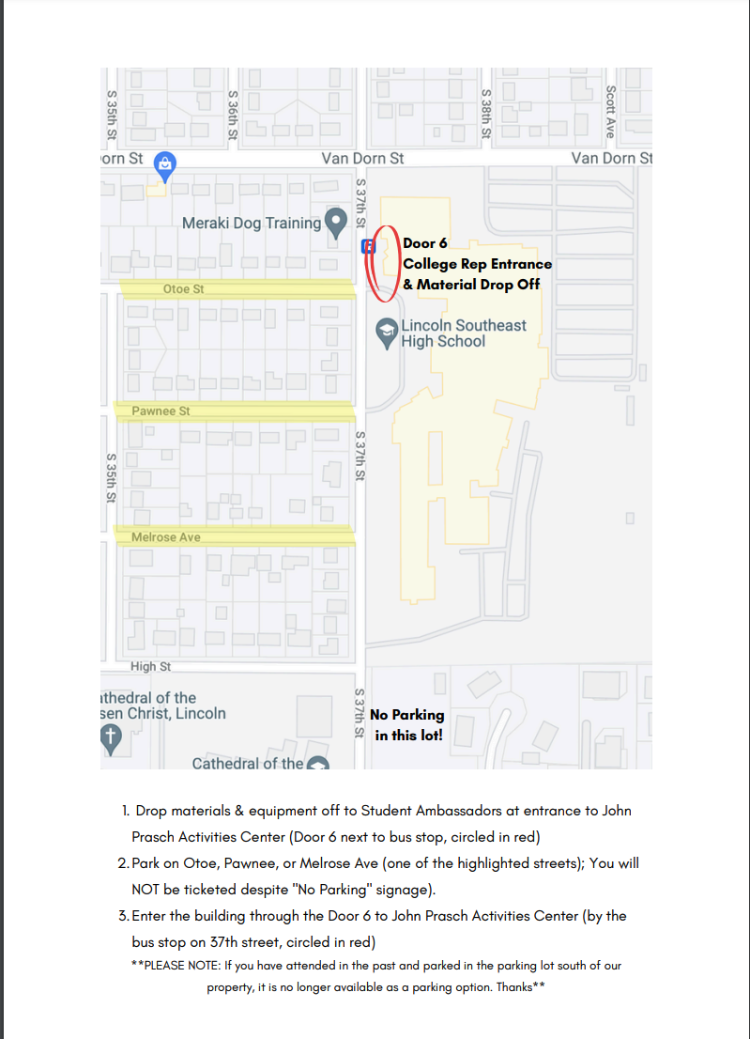

Lincoln Southwest High School College Fair
Time: 1:00 to 2:30am
Location: Lincoln Southwest High School
School Address: 7001 S. 14th St, Lincoln NE
Host Site Contact Information: Amanda Tomes, atomes@lps.org, 402-436-1306 ext 66309
Details: Event participants should park in the Southwest corner of the lot near the tennis courts (see map). Participants can enter through door #3 beginning at 12:30 p.m. We will have Student Ambassadors available to help bring in materials and locate your tables.

High Schools Invited: Southwest High School

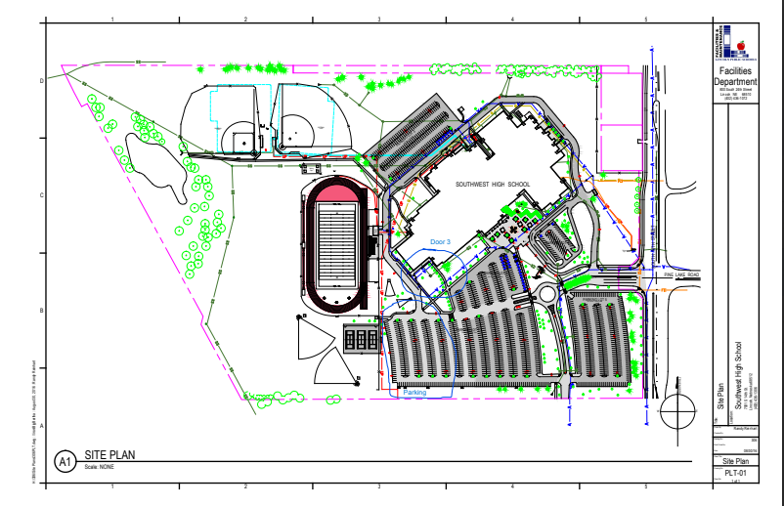

Tuesday, October 6th
Lincoln North Star College Fair
Time: 8:00 to 10:00am
Location: North Star High School
School Address: 5801 N. 33rd St.
Host Site Contact: Sherri Svoboda, ssvoboda@lps.org 402-499-7093
Details: Park in large student lot by the SE corner of the building. Please enter through Door 3 between the hangar and the main building, NOT the main doors (if you come in through the main entrance, you will have to carry your things down a large flight of stairs). External doors are locked, so staff will be at Door 3 beginning at 7:15 am to check you in and direct you to the gym. We do suggest being here before 7:30 to avoid traffic/parking congestion. We will have a 6 ft table and chair for each registered group.

High Schools Invited: North Start High School

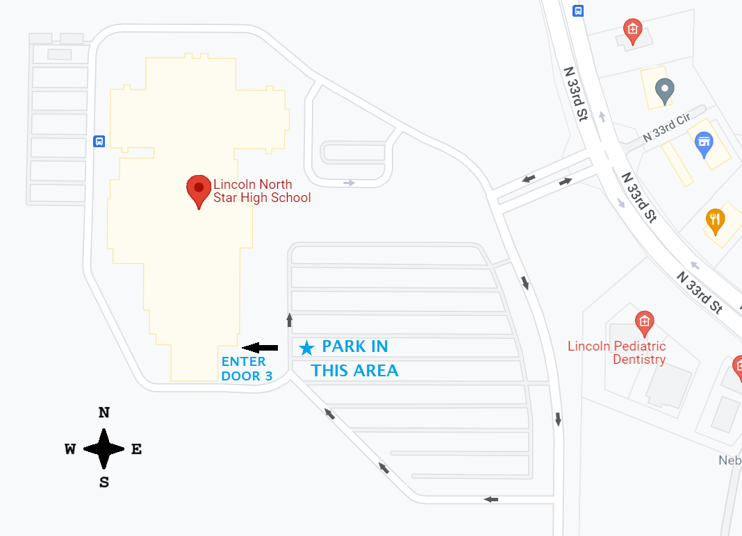

Lincoln Northeast College Fair
Time: 12:30 to 2:30pm
Location: Northeast High School
School Address: 2635 N. 63rd St.
Host Site Contact Information: Ellie Blume, 402-436-1303, eblume@lps.org
Details: Reps may begin setting up any time after 12 pm. Representatives may drop off their supplies at the main entrance (door#1). We will have students helping carry materials from the cars to the Center Gym. Representatives can park at the Easterday Recreation center (see map for directions). Please do not park in the front row closest to the building. You can enter through the main entrance (door #1 by the rocket statue). Our students will be available to help carry items and direct you to the gym as you enter.
High Schools Invited: Northeast High School

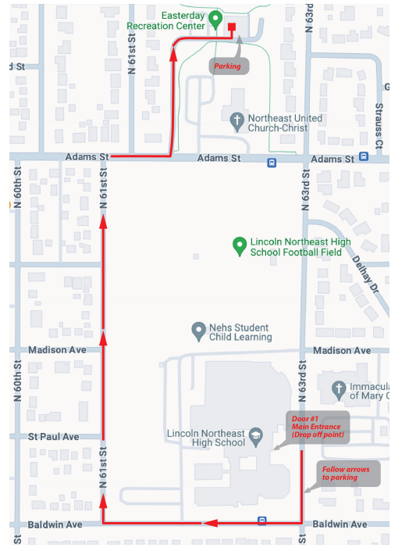

Wednesday, October 7th
Lincoln High College Fair
Time: 9:00 to 11:00am
Location: Lincoln High School
School Address: 2229 J St.
Host Site Contact: Renee McClure; (402) 436-1222, rmcclur@lps.org
Details: We will be using the Johnson Gym this year for our College Fair.
GREAT NEWS! This year everyone can park next to the building so you won’t
need to drop off materials. After you park, you can enter our side door and
student ambassadors will help you bring your materials to Johnson Gym

High Schools Invited: Lincoln High School

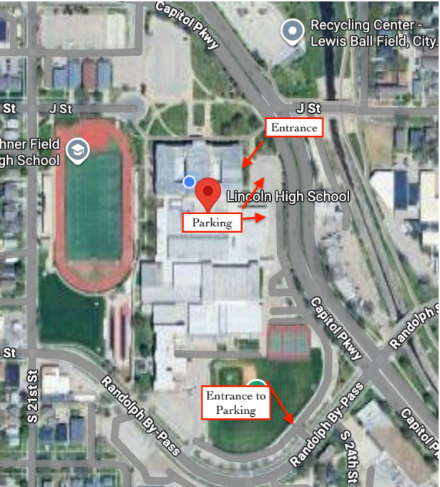

Lincoln Standing Bear College Fair
Time: 1:15 to 2:50pm
Location: Lincoln Standing Bear High School
Address: 11100 S 70th St. Lincoln, NE 68516
Host Site Contact: Riki Schaefer; (402) 436-1315 opt. 3, eschaef@lps.org
Details: College Fair will be in the main gym (160). Representatives may start setting up at 12:45 PM. Representatives may park and enter through Door 1 at our east entrance (If entering off of 70th street you will need to drive around “back” of the building). LSB Student Ambassadors will be available inside of door 1 to help direct you where to go. Please Park your vehicle in the staff parking lot directly outside of door 1 - if you need help carrying in any materials, please let a Student Ambassador know, but do not park in the student drop off zone because we will have buses coming and going during this time. Please see the attached map for parking and building entrance locations.

High Schools Invited: Standing Bear High School. Seniors & Juniors will be allowed to visit the College Fair from 1:15 PM-2:07 PM and then Freshmen & Sophomores will be allowed to visit from 2:08 PM-2:50 PM. We may have approximately 500 students.
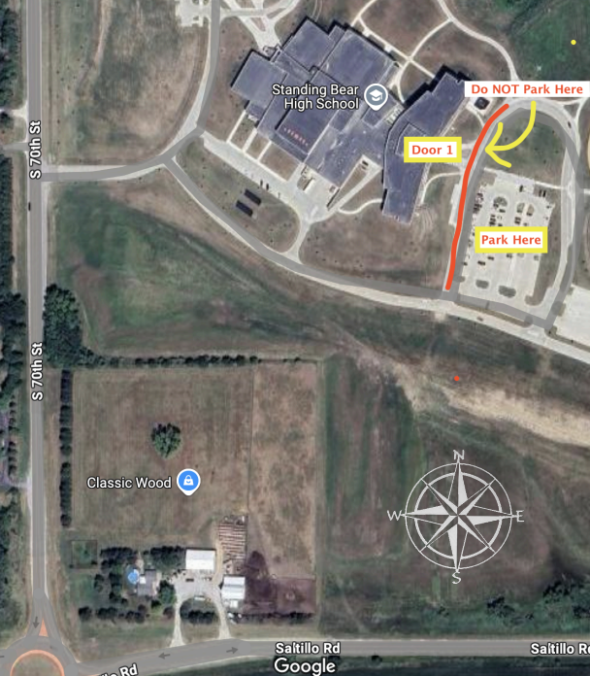

Weekly Social!!
Location: Leighton’s Pub
Address: 4630 Leighton Ave Ste 15 Lincoln NE
Day: Wednesday, Oct 7th
Time: 6:30pm

Thursday, October 8th
Lincoln East College Fair
Time: 9:00 to 10:30am
Location: Lincoln East High School
Address: 1000 S. 70th St.
Host Site Contact: Amanda Ludwig, aludwig2@lps.org, 402-436-1302 ext. 3
Details: Please see below map for parking information. Enter through Door #21 (starred on the map). Participants are welcome to start arriving as soon as 8:30am to begin setting up. Student ambassadors will be available to assist participants to their designated tables. Estimated number of students at the fair: 500+

High Schools Invited: East High School

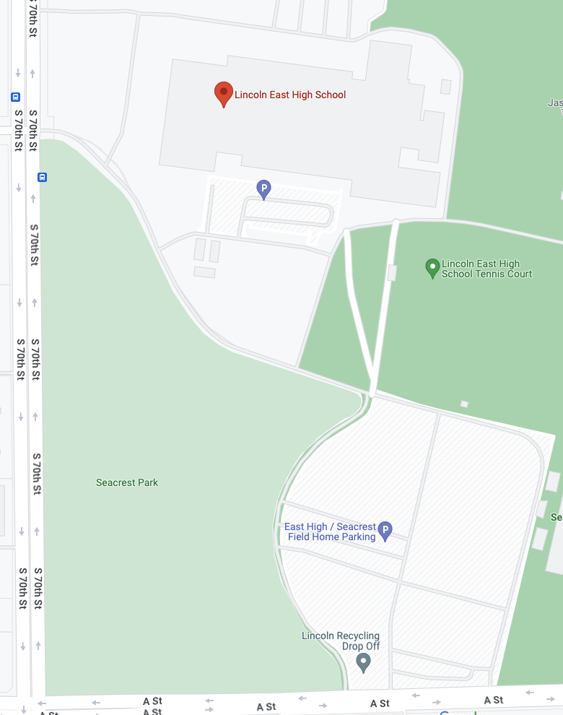

Lincoln Northwest College Fair
Time: 1:30 to 3:00pm
Location: Lincoln Northwest High School
Address: 4901 W Holdrege St, Lincoln NE
Host Site Contact: Shelly Patrick, spatrick@lps.org
Details: When you arrive, please park on the North side of the building and enter through door #1. This is the side of the building that faces Dollar Tree and Sonic. Check in at the security desk. There will be student ambassadors that will direct you to the gym. Please park in a regular spot and not the bus lanes or fire lanes. We will have student ambassadors available if you need to unload your materials before
parking.

High Schools Invited: Northwest High School

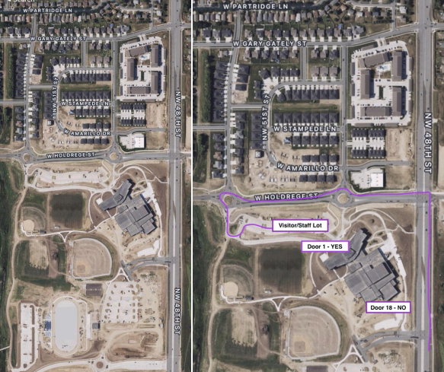

Friday, October 9th
Lincoln Area College Fair
Time: 9:00 to 10:30am
Location: Southeast Community College – Lincoln Campus
Address: 8800 O Street Lincoln NE, 68520
Host Site Contact: Bailey Michaels, bmichaels@southeast.edu, cell phone: 308-367-6543
Details: This event will be held in the gym in the main building. Representatives can either park in the North lot #5 and enter through the T Section doors (facing North) or park in the south lot #1 and enter through the main entrance (facing South with the big SCC logo). The entrances into the building are indicated by the blue stars on the map below. We will have guides to lead you to the gym entrance from there. Reps can start setting up at 8:00am. Please see attached parking pass! Print parking pass and place on your dashboard upon arrival.

High Schools attending: Weeping Water High, Johnson County Central High School, Waverly High School, Elmwood Murdock High School, Dorchester High School.
